Project-2 太鼓達人 Report

遊戲玩法說明與截圖:

1.開始畫面，鼠標點擊exit離開遊戲、help出現遊戲說明、start開始遊戲

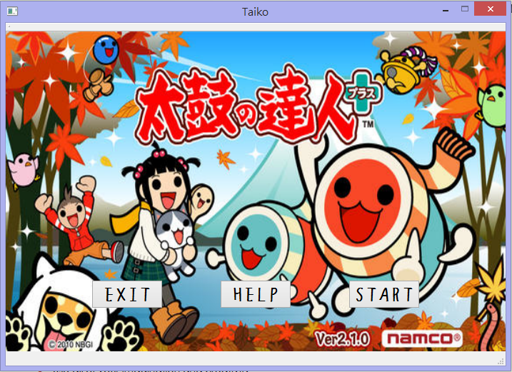

2. 遊戲說明畫面，為彈出視窗，點叉叉可關閉

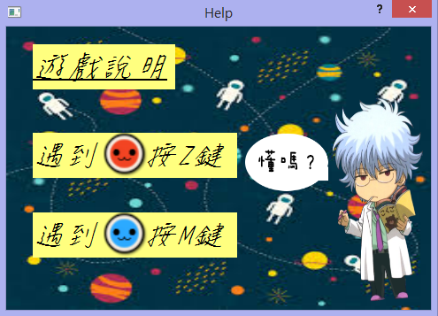

3.遊戲畫面，在白色圈圈遇紅點按Z鍵，遇藍點按M鍵進行遊戲，時間限時30秒

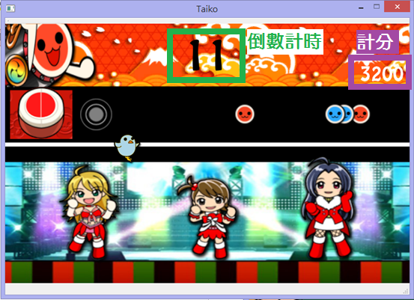

4.分數結算畫面，鼠標點擊restart重新開始遊戲，back返回開始畫面

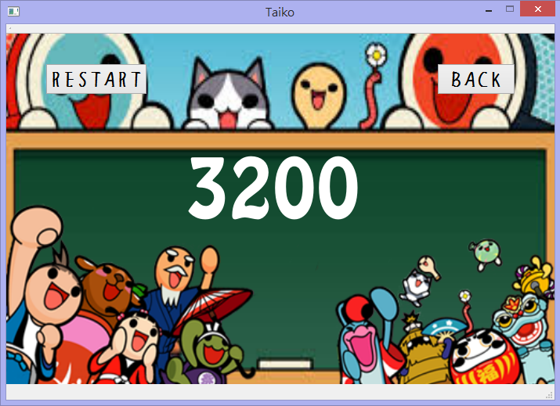

UML class diagram:

|  |
| --- |
| MainWindow |
| - ui: Ui::MainWindow *  - explain: Explain  - start: QPushButton *  - exit: QPushButton *  - help: QPushButton *  - back: QPushButton *  - replay: QPushButton *  - music: QMediaPlayer *  - drum: QLabel *  - reddrum: QLabel *  - bluedrum: QLabel *  - hitPoint: QLabel *  - counter: QLabel *  - countDownTimer: QTimer *  - countTime: int  - redpoint: QLabel *  - redpoint2: QLabel *  - redpoint3: QLabel *  - bluepoint: QLabel *  - bluepoint2: QLabel *  - bluepoint3: QLabel *  - xR: int  - xR2: int  - xR3: int  - xB: int  - xB2: int  - xB3: int  - y: int  - pointTimer: QTimer *  - score: QLabel *  - success: int  - taikoK: QLabel *  - taikokunTimer: QTimer *  - change: int  - river: QLabel *  - river2: QLabel *  - riverSpeed: int  - riverTimer: QTimer *  - girl: QLabel *  - girl3: QLabel *  - pose: int  - chicken: QLabel *  - chickRun: int  - chickPose: int  - girl_chick_Timer: QTimer *  - finalScoreTimer: QTimer *  - gameStatus: bool |
| - *keyPressEvent*(QKeyEvent *event): void  - *keyReleaseEvent*(QKeyEvent *event): void  + explicit MainWindow(QWidget *parent)  + ~*MainWindow*()  + girl_chick():void  + taikokun():void  + countDown():void  + riverTop():void  + scoreTab():void  + points():void  + showScore():void  + gamePage():void  + musicSelect():void  + goToGamePage():void  + backToStart():void  + closeGame():void  + backToGamePage():void  + countDownThirty():void  + pointMove():void  + girl_chick_Move():void  + taikokunMove():void  + riverMove():void  + scoreCount():void  + showHelp():void |

|  |
| --- |
| Explain |
| - ui: Ui::Explain * |
| +explicit Explain(QWidget *parent = 0)  +~*Explain*() |

程式架構說明:

遊戲流程:

MainWindow()中設立開始畫面以及exit、start、help、restart、back按鍵，start的goToGamePage()呼叫gamePage()，gamePage()設立遊戲畫面，當倒數計時器countDownThirty()數到0秒，呼叫showScore()顯示分數畫面，showScore()會將已創建的物件刪除，按下restart重新開始遊戲後才不會造成空間的浪費

各函數說明:

keyPressEvent(QKeyEvent *event)、keyReleaseEvent(QKeyEvent *event)

控制Z、M鍵按下後產生聲音，顯示鼓面，判斷鼓點位置是否加分數

girl_chick()、taikokun()、riverTop()、girl_chick_Move()、

taikokunMove()、riverMove()、points()、pointMove()

遊戲畫面中動圖的設定，利用QTimer進行位置或圖片的變化

countDown()、countDownThirty()

計時器的設定，利用QTimer計時及變化數字，當count==0時跳到分數面

musicSelect()

隨機從5首歌中選取為遊戲音樂